Ottilie (Ryf) Simon
November 18, 1886 – July 30, 1984

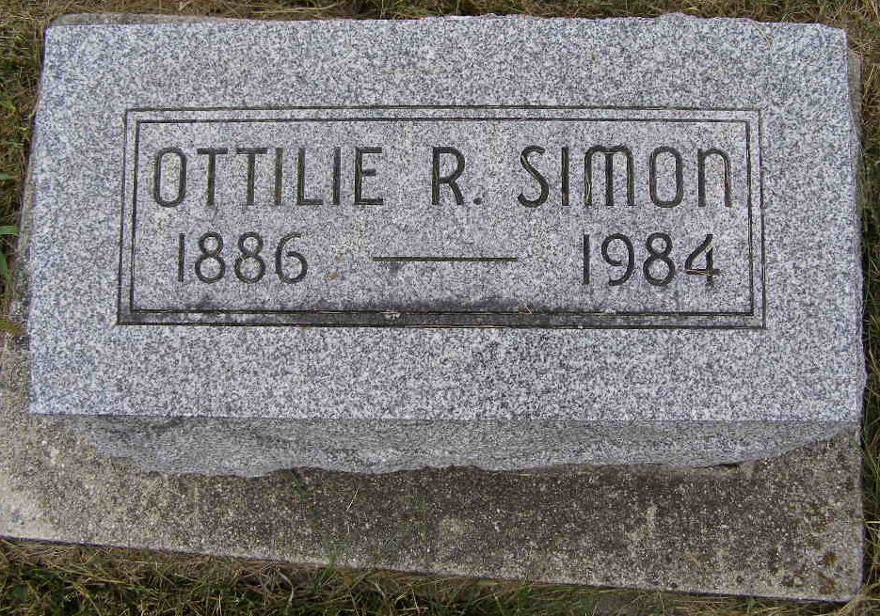
Photo by Shaunda Bedwell Opdycke

Indiana, U.S., Death Certificates, 1899-2017
Name Ottilie R. Simon
[Ottilie R. Ryf]
Gender Female
Race White
Marital Status Widowed
Age 97
Birth Date 18 Nov 1886
Birth Place Indiana
Death Date 30 Jul 1984
Death Place Berne, Adams, Indiana, USA
Death Registration Date 1984
Father Ferdinard Ryf
Mother Lina Badertscher
Informant Omar Reusser, nephew
Burial M.R.E. 8/1/1984

